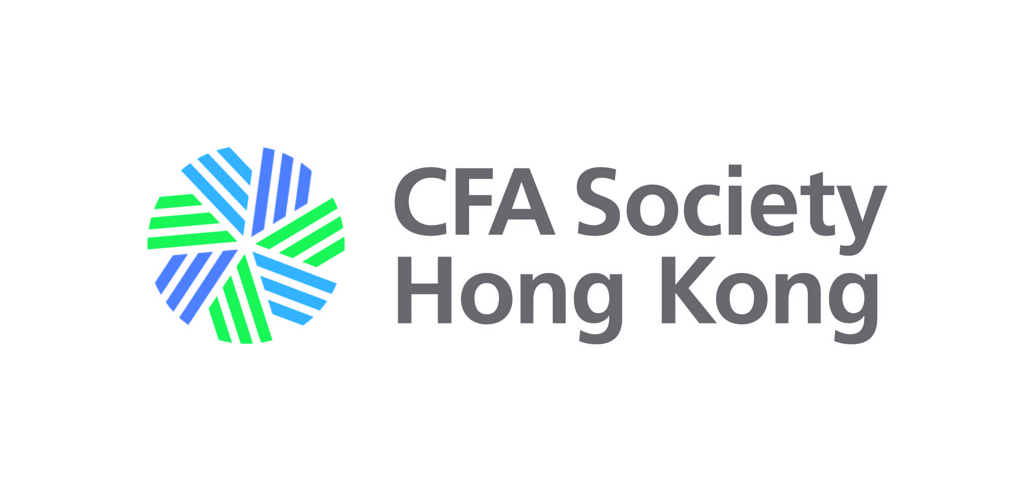
CFA SOCIETY HONG KONG* - ETHICS DECLARATION FOR NEW APPLICANT

Failure to file Ethics Declaration for one year can result in suspension of your membership in CFA SOCIETY HONG KONG*.

Name : Member No. :
First Name Middle Name Last Name

Answer the following questions by ticking the appropriate response for each. Any matter described in the questions below must be disclosed, even if the matter is still pending.

In the last year, have you been :

1. The subject of, a defendant in, or respondent in any investigation, civil litigation, arbitration, or other civil action or proceeding in which your professional conduct, in either a direct or supervisory capacity, was at issue?

No

Yes. Please specify :

2. Temporarily or permanently prevented from : (i) acting as a person required to be registered under any law or regulation (i.e., investment advisor, broker, dealer, etc.); (ii) acting as an employee, registered representative or affiliated person of any entity required to be registered under any law or regulation (i.e., investment company, bank, insurance company, etc); or (iii) working in the securities or investment related industry, or trading on any securities or contract market?

No

Yes. Please specify :

3. Arrested, indicted, or convicted of (i) any felony or other crime punishable by more than one year in prison; or (ii) a misdemeanor involving moral turpitude (lying, cheating, or other dishonest conduct) or any substantially equivalent crime in any court of law?

No

Yes. Please specify :

Member’s Agreement

I have read, understand, and agree to comply with :
(a) the CFA Society Hong Kong Code & Standards and Articles of Association (can be downloaded from CFA Society Hong Kong website here) as amended from time to time; OR
(b) the Code of Ethics (a copy is attached) as a member of (Name of Organisation).

I certify that the above responses and all information provided by me on this Ethics Declaration are truthful, accurate, and complete, and I agree to notify CFA Society Hong Kong promptly of any material changes required in my responses to the foregoing questions. I acknowledge and understand that failure to comply with the CFA Society Hong Kong Code & Standards is grounds for suspension or termination of membership.

Note : For Personal Information Collection Statement, please visit our website here.

Signature : Date :
*The Board of HKSFA has approved on April 20, 2020, to rebrand as “CFA Society Hong Kong” while the entity / legal name, "The Hong Kong Society of Financial Analysts Limited", remains unchanged.

14/F, BOC Group Life Assurance Tower, 136 Des Voeux Road Central, Hong Kong | member@cfahk.org | Tel: (852) 2521-2543

